**SIMPLE QUERY BAG. 2**

1. SELECT * FROM obat ORDER BY harga DESC;

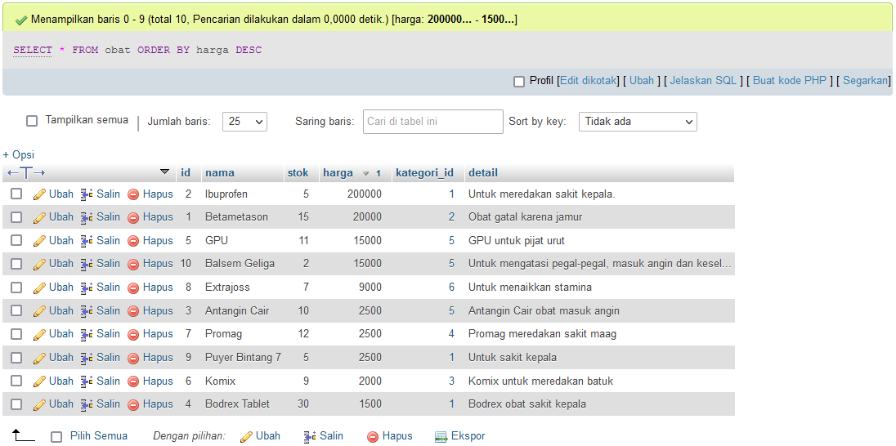

1. SELECT * FROM apoteker ORDER BY umur ASC;

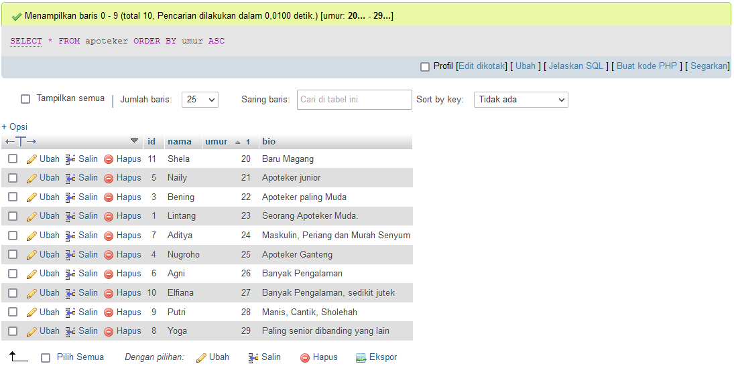

1. SELECT * FROM pembeli WHERE nama LIKE "a%";

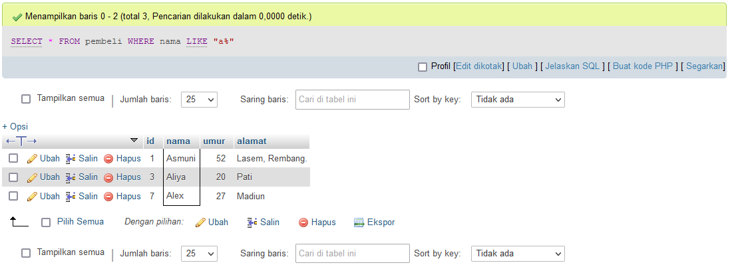

1. SELECT kategori_id, SUM(stok) AS jumlah_stok FROM obat GROUP BY kategori_id;

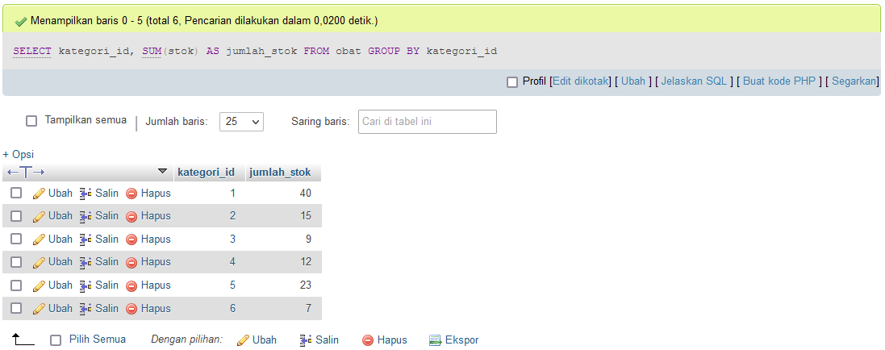

1. SELECT kategori_id, SUM(stok) AS total_stok FROM obat GROUP BY kategori_id ORDER BY kategori_id DESC;

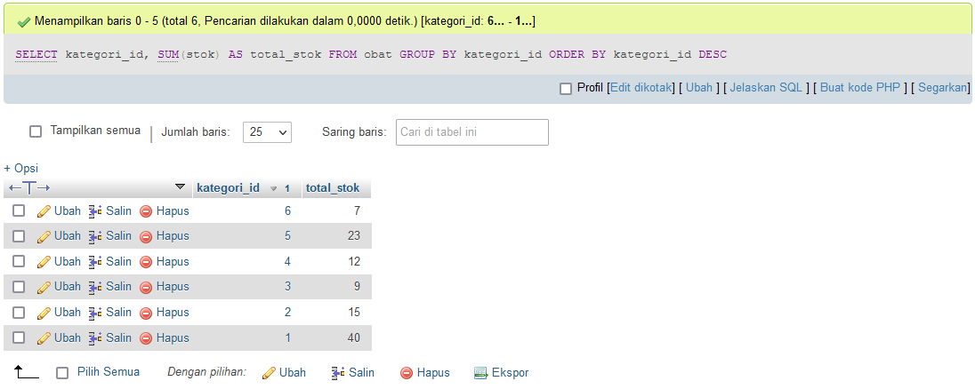

1. SELECT kategori_id, SUM(harga) AS total_penjualan FROM obat GROUP BY kategori_id;

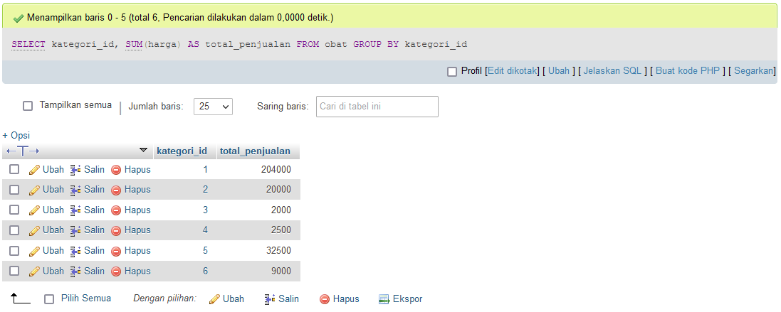

1. SELECT kategori_id, SUM(harga) AS total_penjualan FROM obat GROUP BY kategori_id ORDER BY kategori_id DESC;

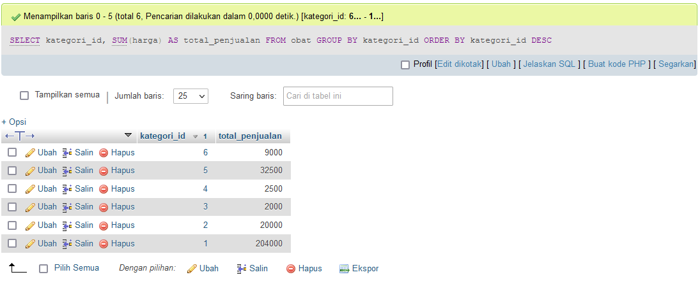

1. SELECT kategori_id, SUM(stok) AS total_stok, SUM(harga) AS total_penjualan FROM obat GROUP BY kategori_id ORDER BY kategori_id DESC;

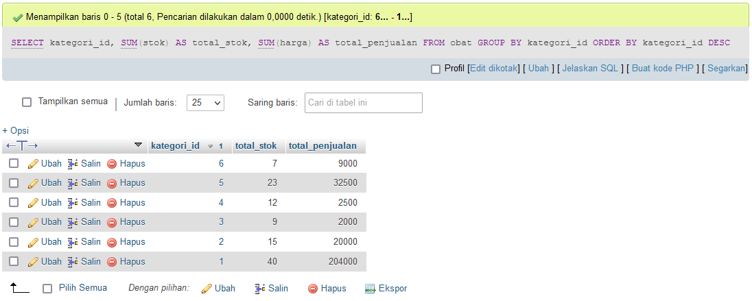

1. SELECT * FROM obat WHERE detail LIKE '%sakit%' ORDER BY nama DESC;

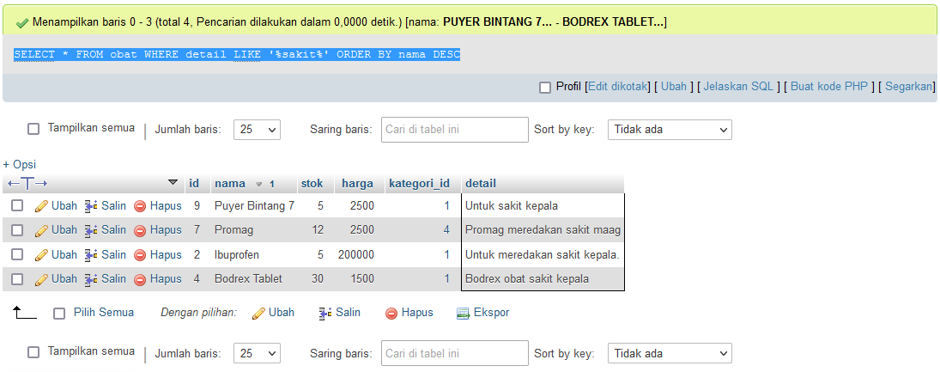

1. SELECT * FROM obat WHERE nama LIKE '%n' ORDER BY id ASC;

